>sudo –i R

>install.packages(“quantmod”)

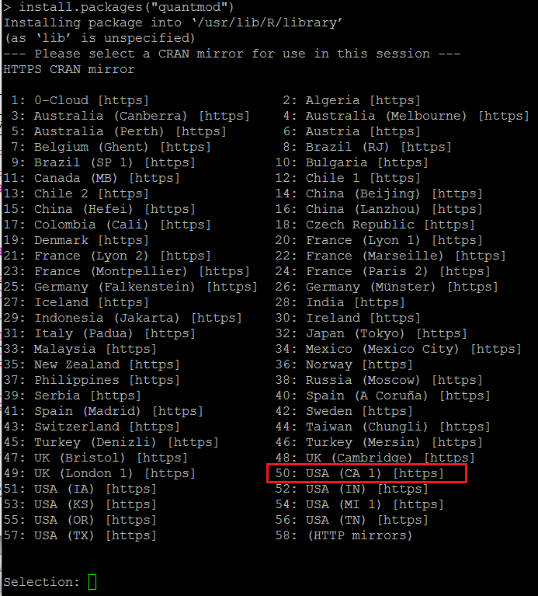

** building package indices

** testing if installed package can be loaded

* DONE (quantmod)

Making 'packages.html' ... done

The downloaded source packages are in

‘/tmp/RtmpdJWZUO/downloaded_packages’

Updating HTML index of packages in '.Library'

Making 'packages.html' ... done

Syntax:

library(object)

str(object)

attach(object)

> library(lattice)

> str(PlantGrowth)

'data.frame': 30 obs. of 2 variables:

$ weight: num 4.17 5.58 5.18 6.11 4.5 4.61 5.17 4.53 5.33 5.14 ...

$ group : Factor w/ 3 levels "ctrl","trt1",..: 1 1 1 1 1 1 1 1 1 1 ...

> attach(PlantGrowth)

> weight